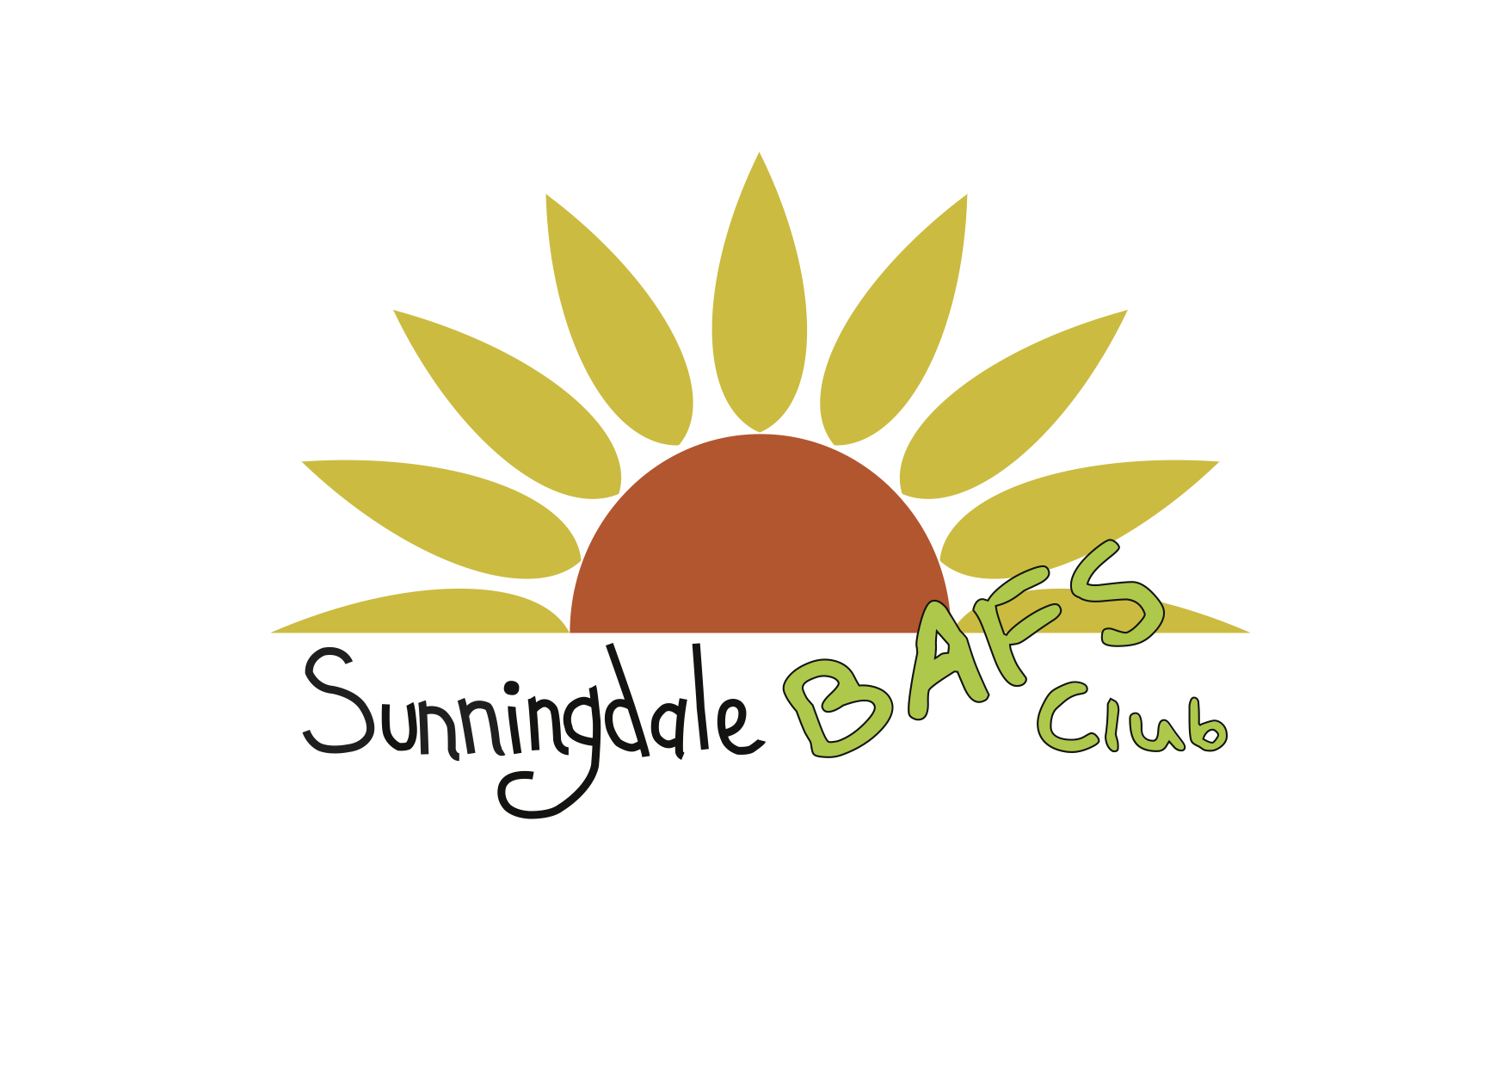

CLUB REQUEST FORM

Child’s Name:………………………………………………………………………………….

D.O.B:…………………………………………………………………………………………..

After School Club Request:

Time Until: 16:00 17:00 17:30
Days: Monday Tuesday Wednesday Thursday Friday
(Please circle)

Parent/Carer Name:………………………………………………………………………….

Contact Numbers:…………………………………………………………………………….

Email Address:………………………………………………………………………………..

Please tick I/we agree to BAFS Terms & Conditions attached to the Prospectus

Village Hall, Church Road, Sunningdale, Berkshire SL5 0NJ
Telephone: (01344) 623331 Registered Charity No: 1021303

